Find the Root

Description
Write an efficient algorithm to solve the following equation (i.e. find the value of x (if exists))
F(x) = p*e^{-x} + q*sin(x) + r*cos(x) + s*tan(x) + t*x² +u = 0
Given that:
- 0 ≤ x ≤ 1
- The function is decreasing in the given interval
- 0 ≤ p,r,u ≤ 20 and -20 ≤ q,s,t ≤ 0
If x is exists, return it, else, return -1.

HINT:
Due to the floating point calculations of the above function, its value at the root may equal very small value but not necessarily equal an exact ZERO. So, you can consider that the root (x) is found if the function value F(x) is:
- eps < F(x) < eps
Where eps is a very small value and already defined in the code by 10⁻⁹

Examples:
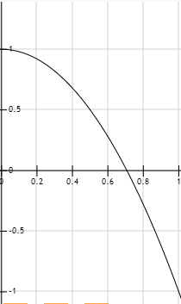  X = 0.7071 | 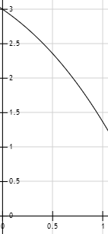  Not Exist | 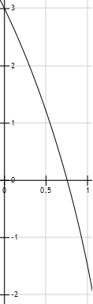  X = 0.7554
p=0, q=0, r=0, s=0, t=-2, u=1 | p=1, q=0, r=0, s=0, t=-1, u=2 | p=1, q=-1, r=1, s=-1, t=-1, u=1

Input: Already Implemented
Input consists of multiple test cases and terminated by an EOF. Each test case consists of 6 integers in a single line: p, q, r, s, t and u (where 0 <= p,r,u <= 20 and -20 <= q,s,t <= 0).
Output: Already Implemented
For each set of input, there should be a line containing the value of x, correct up-to 4 decimal places, or -1 if not exists, whichever is applicable.
Given Function: Already Implemented
static double f(int p, int q, int r, int s, int t, int u, double x)

It calculates the above function F(x) at a given (double x) value with the given six parameters (p, q, r, s, t and u) and return the result.
Required Function: Implement it!
double findTheRoot(int p, int q, int r, int s, int t, int u)

It takes the six integers (p, q, r, s, t and u) and should return the value of the root (x) that satisfies F(x) = 0 (or return -1 if x is not exists).

Template
- C# template

Test Cases
# | Input | Output
1 | 0 0 0 0 -2 1  1 0 0 0 -1 2  1 -1 1 -1 -1 1 | 0.7071  -1  0.7554
2 | 16 -1 12 -2 -12 4  4 -9 10 -2 -4 8  4 -15 19 0 -5 6  10 -5 20 -2 -11 4  16 -4 18 -7 -2 1  17 0 6 -8 -4 7  20 -3 5 -6 0 2  8 -7 18 -3 -12 10 | -1  -1  -1  -1  -1  -1  -1  -1
3 | 1 -20 3 -20 -5 6  2 -20 3 -20 -5 6  3 -20 3 -20 -5 6  4 -20 3 -20 -5 6  5 -20 3 -20 -5 6  6 -20 3 -20 -5 6  3 -4 1 -3 -2 5  6 -11 8 -20 -3 1  4 -4 4 -4 -4 5  17 -6 2 -8 -1 3  16 -1 12 -2 -12 4  4 -9 10 -2 -4 8  4 -15 19 0 -5 6 | 0.2347  0.2521  0.2689  0.2850  0.3005  0.3154  0.7863  0.3807  0.8016  0.7628  -1  -1  -1

C# Help
If you need any help regarding the syntax of C#, ask any TA.

Creating 1D array
int [] array = new int [size]

Creating 2D array
int [,] array = new int [size1, size2]

Sorting single array
Sort the given array in ascending order
Array.Sort(items);

Sorting parallel arrays
Sort the first array "master" and re-order the 2nd array "slave" according to this sorting
Array.Sort(master, slave);

